**Microstimulation & Optogenetics Optimization using particle swarm optimization**

Best cost represents the # of non-motion neurons, given that 45 motion-tuned neurons must be activated

<https://www.mathworks.com/help/gads/particleswarm.html>

Microstimulation Alone:



Optogenetics after microstimulation optimization:



Microstim + Opto optimization together:



**Oscillatory Neurons**

<https://www.ncbi.nlm.nih.gov/pmc/articles/PMC4409360/#sec004>



r 0 is the baseline firing rate, 0 ≤ m ≤ 1 is the modulation index, and f 0 is the oscillation frequency

The results of the detection of oscillatory neurons using the modulation index indicate that it is dependent on the baseline rate, such that the detection is better for higher firing rates ([Fig 4C](https://www.ncbi.nlm.nih.gov/pmc/articles/PMC4409360/figure/pcbi.1004252.g004/)). For example, when the modulation is 0.4, and the required detection probability is 80%, the firing rate should be higher than 15 spikes/s

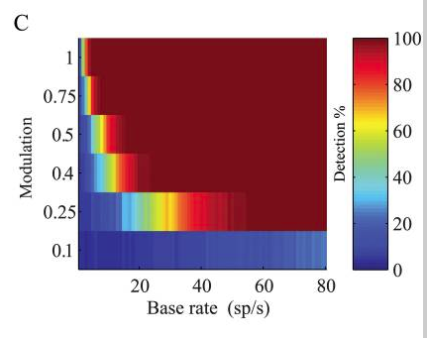

AKA as we increase base firing rate, we decrease the modulation rate necessary for the generation of a reliable spectrum

Therefore I used modulation rate = 1 to best view the oscillation

The neuron will have a frequency of 35 – 45 Hz every trial

function Spikes = Oscillatory_PoissonGen(Firing_Rate, dt, NumTrials)

dur = 1;

modIndex = 1; % Higher modulation = higher variability in sine wave

NumSteps = 1/dt; % Number of time steps

t = 1:1:NumSteps; % Time vector

Freq = randi([35 45],NumTrials,1); % Gamma Hz Oscillation

Spike_Probability = (Firing_Rate * (1/dur) * (1 + modIndex .* cos(2*pi * Freq * t/NumSteps))) * dt; % Probability of spike occuring in time step

X_random = 1 + (0-1).*rand(NumTrials,NumSteps); % Random Number that spike probability must overcome

Spikes = (X_random < Spike_Probability); % 1 = spike, 0 = no spike

Trial_Spikes = sum(Spikes, 2); % Sum of all spikes per trial

end

This figure shows the probability of a spike occurring in the time series



The following figure is the PSD for one neuron



Various PSDs:









**Proposed paper for journal club:**

<https://iopscience.iop.org/article/10.1088/1741-2552/ab4d99/pdf>

Object stiffness recognition using haptic feedback delivered through transcutaneous proximal nerve stimulation

**Abstract**

Haptic feedback is crucial when we manipulate objects. Information pertaining to an object’s stiffness in particular can help facilitate fine motor control. In this study, we seek to determine whether objects of different stiffness levels can be recognized using haptic feedback provided by transcutaneous electrical stimulation of peripheral nerves. Approach. Using a stimulation electrode grid placed along the medial side of the upper arm, the median and ulnar nerve bundles were targeted to evoke haptic sensation on the palmar side of the hand. Stimulation current amplitude was modulated in real-time with the fingertip force recorded from a sensorized prosthetic hand. In order to evaluate which stimulation pattern was more critical, object stiffness was encoded either by the rate of change of the stimulus amplitude or the level of peak stimulus amplitude, as the prosthesis grasped the objects. Main results. Both encoding methods allowed the subjects to differentiate objects of different stiffness levels with >90% accuracy. No significant difference was observed between the two encoding methods, which indicated that both the rate of change of the stimulation amplitude and the peak stimulation amplitude could effectively provide stiffness information of the objects. Significance. The outcomes suggest that it is possible to elicit haptic sensations describing various object stiffness levels using transcutaneous nerve stimulation. The haptic feedback associated with object stiffness can facilitate object manipulation/interactions. It may also improve user experience during human–machine interactions, when object stiffness information is incorporated.